Cataract Surgery:
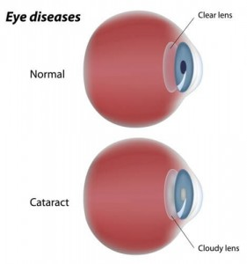
A cataract forms when the naturally clear lens of the eye becomes cloudy. It causes painless but progressive loss of vision. Other symptoms include glare, halos, needing more light to read, decrease color perception, and frequent changes in eyeglass prescription. Cataracts are quite common among adults 60 and older; in fact, everyone will ultimately develop a cataract if they live long enough. Cataracts are generally caused by the natural aging process, but can occur with certain medical conditions, after trauma, after intraocular eye surgery, or after using certain medications.

Dr. Rapoport performs surgical removal of the cataract and implants a replacement lens as an outpatient procedure in the operating room. During this procedure, the cataract lens is broken into small fragments and removed from the eye using a combination of laser and an ultrasound probe through a microscopic incision in the front of the eye. The cataract is then replaced with a foldable, lens implant to restore the function of the natural lens that was removed. Surgery and the post-operative healing period are usually associated with only minor discomfort. Patients are usually able to resume normal activities the next day. The lens implant takes some time to stabilize within the eye, so optimal visual recovery occurs within a month. Cataracts are typically present in both eyes. Surgery in the fellow eye may be required within several weeks or possibly not for years after surgery in the first eye.

Dr. Rapoport is a cataract surgery expert and has extensive expertise in refractive cataract surgery. Nowadays, besides just removing the cloudy leans, you have the ability to correct your vision so that your reliance on glasses is minimal. She does this using when appropriate a combination femtosecond laser assisted cataract surgery to correct astigmatism, and a variety of intraocular lenses such as toric lenses (to correct astigmatism), multifocal, trifocal, and extended depth of field lenses. Dr. Rapoport has experience implanting both the Symfony and the Alcon Panoptix lens, the newest FDA-approved lens that is providing excellent distance and near vision. Dr. Rapoport takes meticulous measurements and calculations at your cataract surgery consultation, and guides each patient to a well-informed individualized surgical plan, taking into account your specific ocular circumstances and visual goals.

Additionally, Dr. Rapoport is one of the first surgeons in New York City to successfully use the Ocular Therapetuix’ Dextenza insert routinely after cataract surgery to minimize the quantity and length of time that a patient has to be on drops after surgery. Dr. Rapoport inserts this device at the end of surgery by and it time releases a steroid medication over the course of the month after surgery. This allows for most patients to not need a steroid drop post –operatively.
In the past, patients had to be on up to 3 drops for 6 weeks. Now most patients will only need to be on 1 drop for a week post-operatively. This is a huge relief for patients who struggle to put drops in, for various reasons such as cost, cosmesis, poor dexterity, discomfort, corneal toxicity, or forgetfulness.
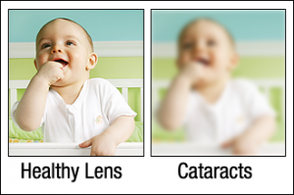
Monofocal (standard single vision lens):

Most common is the standard single focus lens implant which gives the surgeon the opportunity to correct the patient for either distance vision in both eyes or for near vision in both eyes. This means you would then need to wear glasses for near (if corrected for distance), or wear glasses for distance.

Presbyopia:

Presbyopia is when your eyes gradually reduces its ability to read up close. It is a normal part of aging. This typically begins by mid-40s. The clear lens sits behind the iris, the colored part of the eye. When you are young, the lens is soft and flexible, easily changing shape. This lets you focus on objects both at distance and at near. After age 40, the lens becomes more rigid and cannot change shape as easily. This makes it harder to read or do any work up close. There is no way to pause or stop this naturally occurring process. Bifocals, contact lenses, LASIK, or cataract surgery are ways to correct presbyopia, thus not requiring reading glasses.

Customizable vision in cataract surgery aims to minimize the need for glasses after surgery. Dr. Rapoport spends time with each patient to develop an individualized plan to determine the best outcome for each person. Below are some of the tools offered:

Monovision:

With monovision, Dr. Rapoport corrects your dominant eye for seeing at distance and your non-dominant eye for near vision, thereby reducing the need for reading glasses. When both eyes are functioning together, the brain naturally selects the image from the eye that has the clearer focus. Having eyes for different purposes might sound unsettling, but many patients do very well with monovision.

Blended vision simply refers to monovision with a smaller discrepancy between the eyes, increasing the need for reading glasses but making it easier to adjust to the difference between the two eyes.

Monovision and blended vision are common goals for patients over the age of 40, allowing patients to achieve good functional vision at both distance and near without the need for glasses or contact lenses.

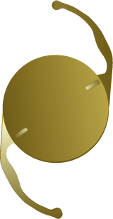
Toric – astigmatism correcting lens:

Advanced technology makes it possible to correct
the cataracts that may be clouding your vision –
and the astigmatism that may be distorting your vision –
all at the same time. The Toric intraocular lens replaces
your eye’s natural clouded lens during cataract surgery.
It also has the ability to reduce or eliminate corneal
astigmatism at the same time it corrects cataracts.
Typically the result is improved distance vision and less
dependence on eyeglasses. However, most
patients still require corrective lenses for near and
intermediate tasks. With the Toric lens, your distance
vision can now be clear and vibrant following cataract
surgery.

Trifocal/ Extended Depth of Field Lenses:

There are currently two lenses in the USA that are Trifocal or Extended Depth of Field Lenses – Alcon’s Panoptix and Johnson & Johnson’s Symfony Lens. Both of these lenses are excellent choices for patients with active lifestyles, from requiring precise distance vision for sporting activities, to viewing mobile devices and computer screens. The near vision with these lenses is not at the same level as that of multifocal lenses, but there is less risk of glare/ halos or of compromise in distance vision.

Alcon Panoptix:
The Panoptix lens was FDA-approved in August 2019, having been used for many years in over 70 countries Similar to the Symfony lens below, is the first approved “Trifocal Intraocular Lens. Panoptix is clinically shown to deliver an exceptional combination of near, intermediate and distance vision, reducing the need for glasses after surgery. While the lens implant looks like a multifocal lens, the optics work differently. Instead of producing two distinct focal points, the lens uses ENLIGHTEN 9R) Optical Technology, proprietary design that optimizes intermediate vision without compromising near and distance vision. It can correct both spherical and astigmatic corrections, and builds on Alcon’s proven AcrySof IQ IOL platform. With this lens, patients, can achieve excellent clarity at distance and a range of clear vision at near for patients receiving the lens. The unique technology allows for reading vision that is at a level in between the Symfony and the traditional multifocal lenses. Dr. Rapoport is one of the first group of surgeons in NYC to implement this lens with success in her practice.
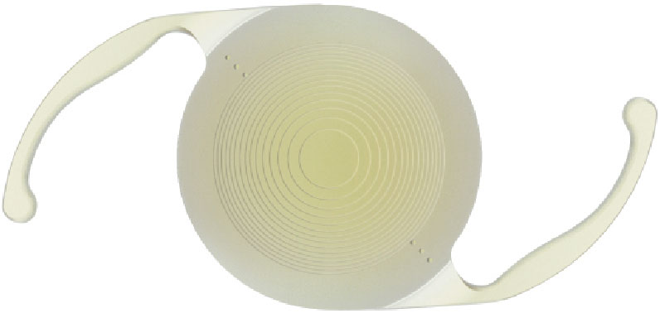

Johnson & Johnson Symfony Lenses:

The Symfony lens was the first lens to be approved by the FDA with the designation “extended range of focus” intraocular lens. Similarly to the Panoptix, while the lens implant looks like a multifocal lens, the optics work differently. Instead of producing two distinct focal points, the lens can achieve excellent clarity at distance and a range of clear vision at near for patients receiving the lens. The arrival of the Symfony lens is welcomed news because many patients who were not good candidates for a multifocal lens may, in fact, be very good Symfony candidates. One specific group of patients consists of cataract patients with significant astigmatism.

Our expectations for extednded depth of field patients are that they should be able to pass a driver’s test, navigate their cell phone, perform most computer tasks, and read their Ipad without the need for glasses. A multifocal lens can be considered a bit stronger than the Panoptix or Symfony with regards to its ability to provide newspaper or paperback book reading vision to implanted patients. While complete spectacle independence is often our goal with our refractive cataract surgery patients, we are, of course, unable to guarantee any specific outcome. Like multifocal lens patients, patients undergoing Panoptix or Symfony lens implantation need to understand that they may see some halos/rings around lights when driving at night. Fortunately, the incidence of persistent and troublesome night vision disturbances is uncommo

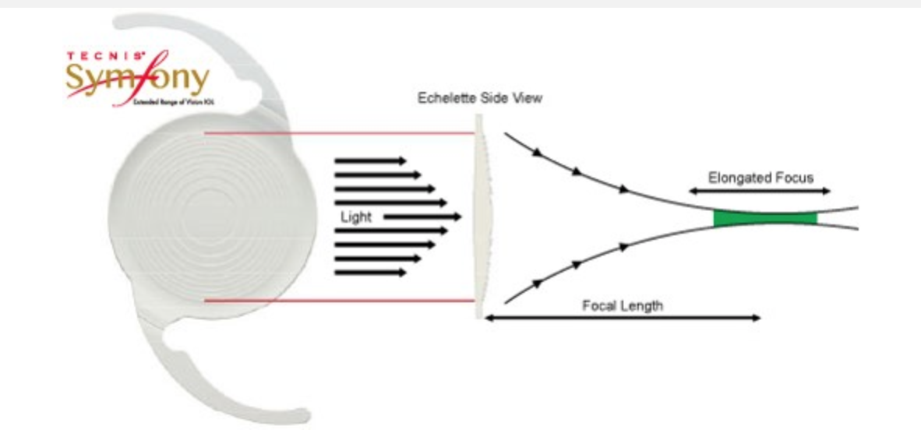

Multifocal Lenses:
AcrySof® ReSTOR® IOL:

The AcrySof® ReSTOR® (Alcon) lens, FDA approved since 2005 is an intraocular lens (IOL) that corrects cataracts, with or without presbyopia. Presbyopia is the reason many patients need reading glasses as their eyes age. The result is clear vision near, far, and everywhere in between.

These multifocal lens implants feature a patented "apodized diffractive" design that optimally distributes light to distance, intermediate and near focal points, depending on the amount of ambient light available. This optimizes image quality in all lighting conditions, according to Alcon.
For example, in low-light conditions, as the pupil dilates, more light is distributed to elements in the lens required for clear distance vision. This improves a driver's vision of the road ahead at night, the company says. But this also means near vision may not be as crisp with the ReSTOR lens in low light as it is in bright light conditions.

AcrySof IQ ReSTOR multifocal IOLs also feature aspheric optics to reduce a specific type of higher-order aberration called spherical aberration. This reduces halos around lights at night and improves image quality for enhanced visual clarity, the company says.
More than 93 percent of people who have had AcrySof IQ ReSTOR multifocal IOLs implanted in their eyes during cataract surgery have said they would do it again, according to Alcon.

Additionally, 4 out of 5 patients in the supporting clinical study who had the AcrySof® ReSTOR® lens implanted in both eyes reported never wearing glasses again.

Tecnis Multifocal:

The Tecnis Multifocal IOL, marketed by Abbott Medical Optics (AMO), has been approved for use in the U.S. since 2009. The advanced TECNIS Multifocal Lens is an excellent option for cataract and presbyopic patients and can provide excellent vision at near, intermediate and far distances under all lighting conditions … day and night. The TECNIS Lens allows people to read a menu in a dimly lit restaurant, take a walk at dusk and even drive at night. Most importantly, the TECNIS Multifocal Lens has allowed thousands of people to achieve independence from glasses. The fully diffractive surface of the Tecnis Multifocal IOL provides advanced image quality at all distances under any lighting conditions and regardless
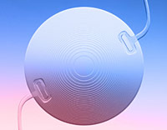
of pupil size, according to AMO.
Nearly 9 out of 10 people who have had Tecnis Multifocal IOLs implanted in their eyes enjoy freedom from eyeglasses after cataract surgery, the company says.

Are You a Good Candidate for Multifocal IOLs?

Perhaps the most important factor in determining if you are a good candidate for multifocal IOLs is your willingness to accept some compromise in the clarity of your distance vision for the convenience of being less dependent on computer glasses and/or reading glasses after cataract surgery.

If you're not willing to accept this type of compromise, or your occupation requires that you have the best possible distance vision at all times or excellent night vision — for example, if you are a pilot or someone who spends a lot of time driving in unfamiliar areas at night — then you probably are not a good candidate for multifocal IOLs. You may be better served with standard monofocal IOLs for optimal distance vision — even though this means you will need bifocals, progressive lenses or reading glasses to see clearly up close.

Also, if you have a pre-existing visual condition other than cataracts that affects your vision in one or both eyes (macular degeneration, or an epiretinal membrane, or example), you typically will be happier with standard monofocal IOLs rather than multifocal IOLs, which require good visual capability in both eyes for best results

Laser-assisted Cataract Surgery:

Laser-assisted cataract surgery is sometimes called “femtosecond cataract surgery” or “femtosecond- assisted cataract surgery.” Using laser- assistance during cataract surgery allows for a more gentle and precise approach in which the laser performs many of the steps that otherwise must be done manually. Specifically, the laser can be used to create the opening in the capsular bag which contains the lens and can be sued to soften the lens, thus requiring less ultrasound energy to break up the lens in the eye, resulting in less potential damage to the cornea. The laser-assisted technique may be particularly beneficial in patients with Fuchs’ Dystrophy or cataracts which have become very advanced or white (mature).

In patients with corneal astigmatism, the laser can be used to make incisions in the cornea which may reduce or eliminate this astigmatism, thus decreasing the reliance on glasses or contacts. In patients who do not have enough astigmatism to require a toric intraocular lens, but enough that they will still require glasses or contacts, the femtosecond lens is a great option to eliminate this astigmatism.

Furthermore, for the best visual outcomes with toric and multifocal IOLs, the exact placement of the lens inside the eye is critical — more critical than when a monofocal IOL is used. Use of a femtosecond laser during certain steps in cataract surgery can help us better position the toric or multifocal IOL to take full advantage of the design of the lens for optimal vision.

We feel it is important to stress that everyone’s eyes and visual needs are different. After thoroughly evaluating your ocular situation and discussing your visual goals, we will explain the benefits and limitations of the available lens implants for your specific case and help you select the best option.

