**Dr. Rapoport Post- Cataract instructions**

Week 1: Prednisolone acetate 4x/day (shake it)

Ofloxacin 4x/day

Shield over eye at night

No exercise

Careful with dirty water from shower in eye

Week 2: Prednisolone acetate 3x/day

Stop Ofloxacin

If suture removal then Ofloxacin 3x/day 3 more days

Exercise OK

Shower without precautions OK

Stop shield at night

Week 3: Prednisolone acetate 2x/day

Week 4: Prednisolone acetate 1x/day

Week 5: Swimming, hot tub, sauna OK

**Prednisolone Acetate:**

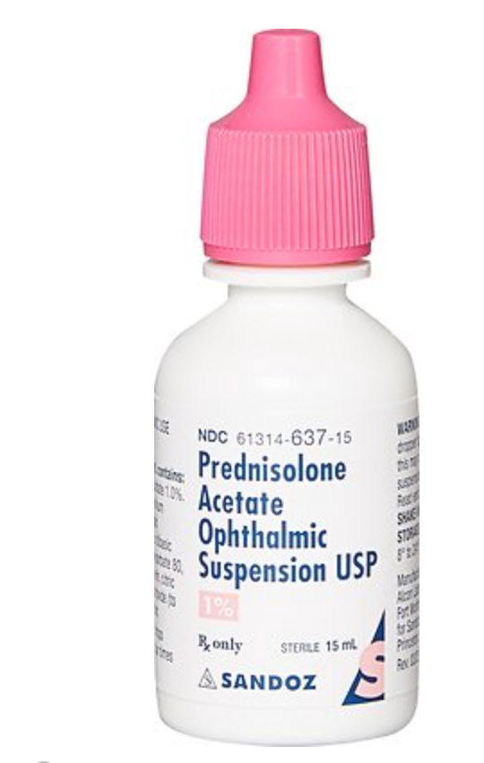

**Ofloxacin:**

